**Versa64case v2 Rev. 0**

**Module description**

# Introduction

The Versa64case v2 is my 2nd approach to a 3D printed case for the Versa64card by bwack. The Versa64cart can be found here: <https://github.com/bwack/Versa64Cart>

The goal was to develop a case, that is less complicated than the first case from 2019 and only consist of two parts while offering fill access to the DIP-switch and the configuration jumpers. Also, a closed version without this access is required, in case no configuration change is desired or for the Epxy Fast Load cartridge (which can be found here: <https://github.com/svenpetersen1965/Epyx-FastLoad>).

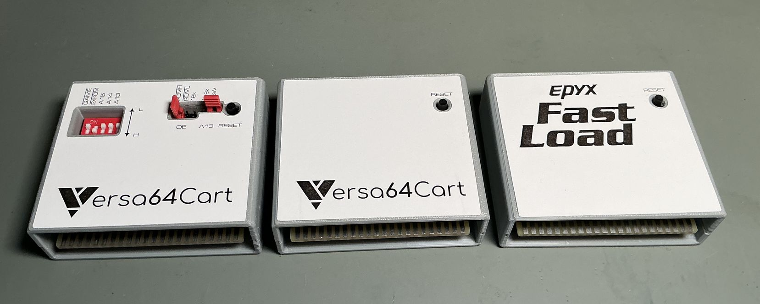

Figure 1: All versions of the case with labels

# Versa64case With Full Configuration Access

This version allows to access the DIP-switch and the configuration jumpers. For the easiest way to change the configuration, it is best to use jumpers with a “handle”, which protrude over the case. They are available from multiple sources and manufacturers (e.g. Reichelt MPE 149-4-002-F0 or Ali Express [product URL](https://de.aliexpress.com/item/1005006390258256.html?channel=twinner)).

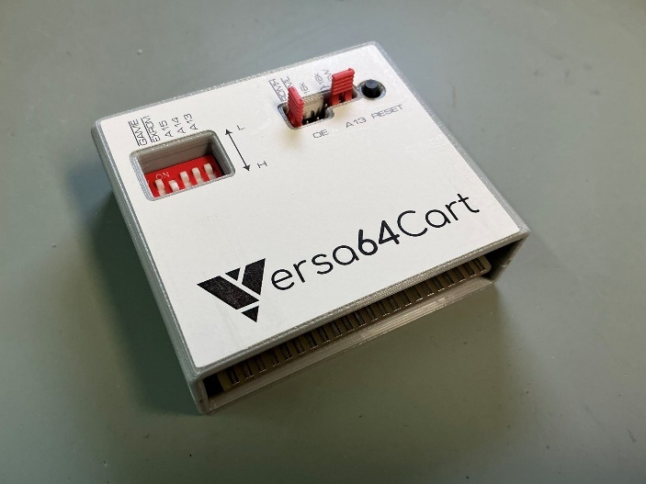

Figure 2: Version with full configuration access

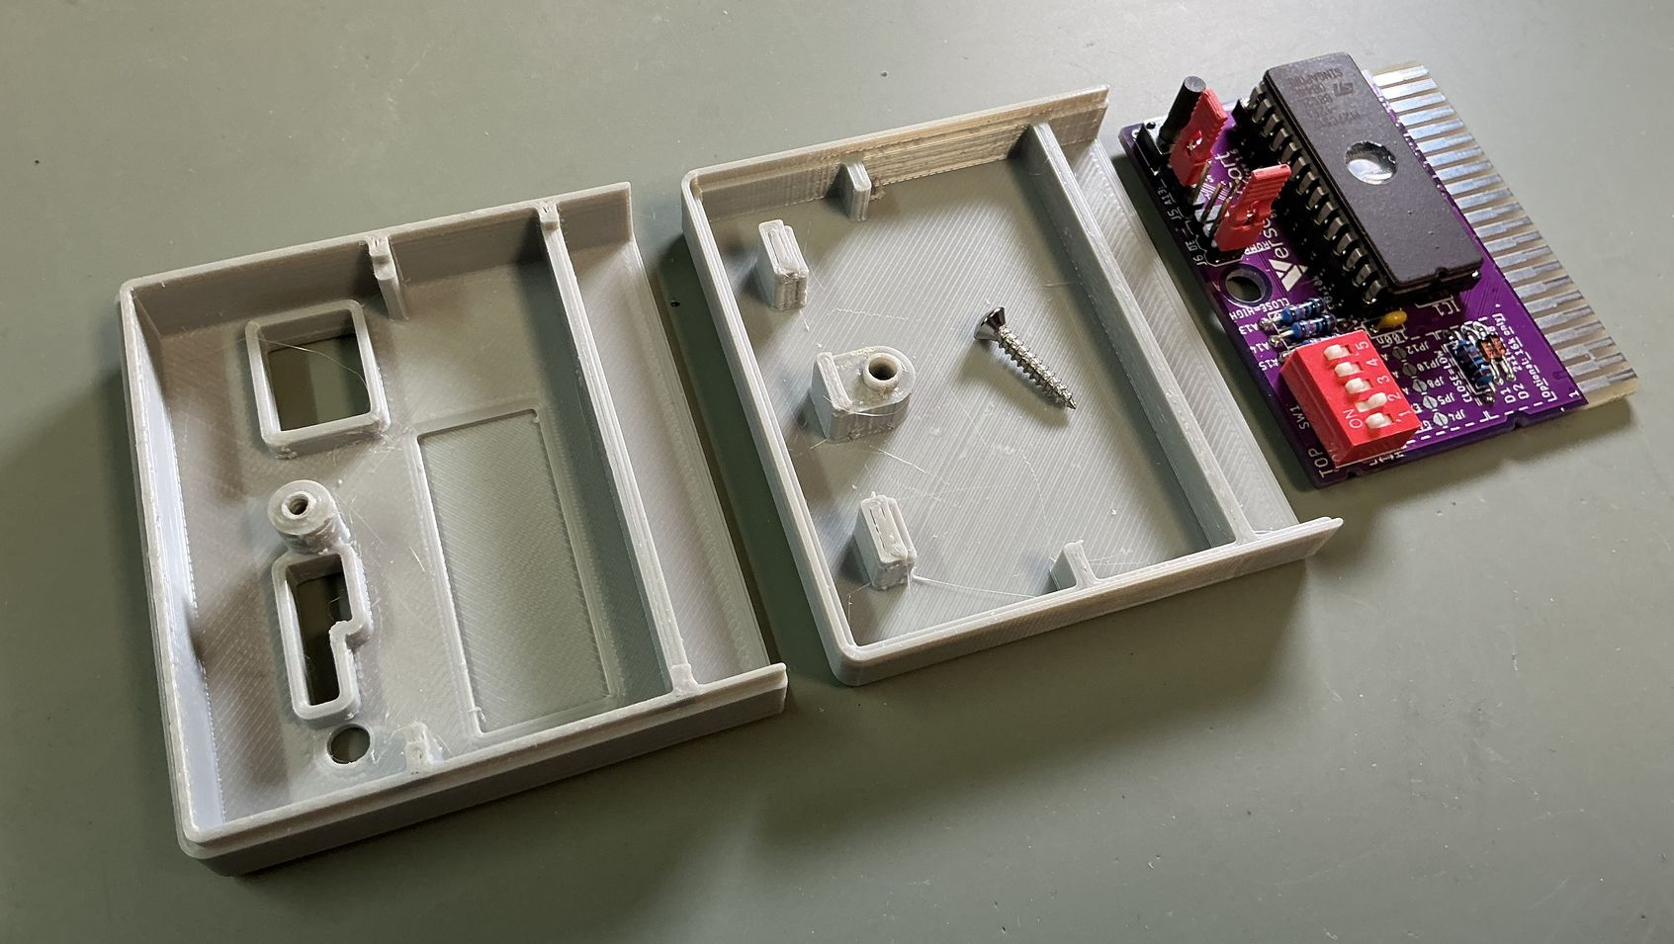

Figure 3: Version with full configuration access (internal)

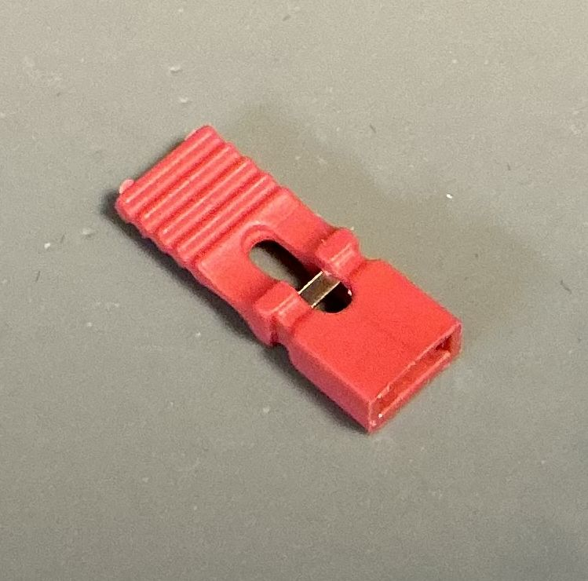

Figure 4: Jumper with handle

# Versa64case Without Configuration Access

This version does not allow changing the configuration of the Versa64cart without opening the case, which might be a desirable option for some projects.

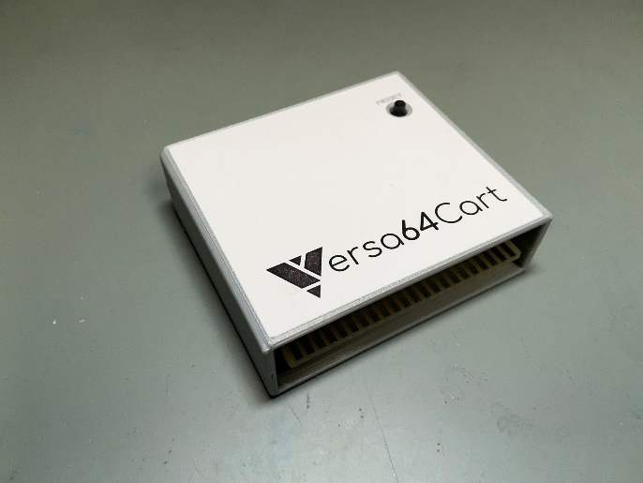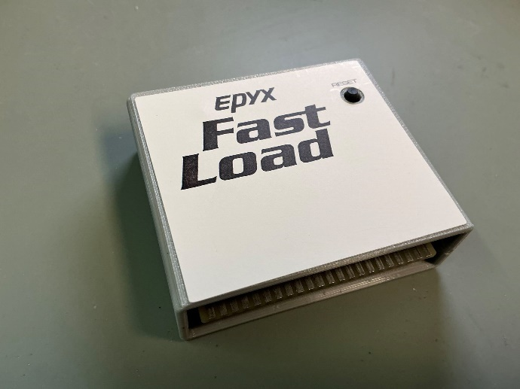

Figure 5: Versa64Case without configuration access

The Epyx FastLoad cartridge, which was mentioned before, does not require accessing any configuration and has the same form factor of the Versa64Cart. There is an extra version of label for it.

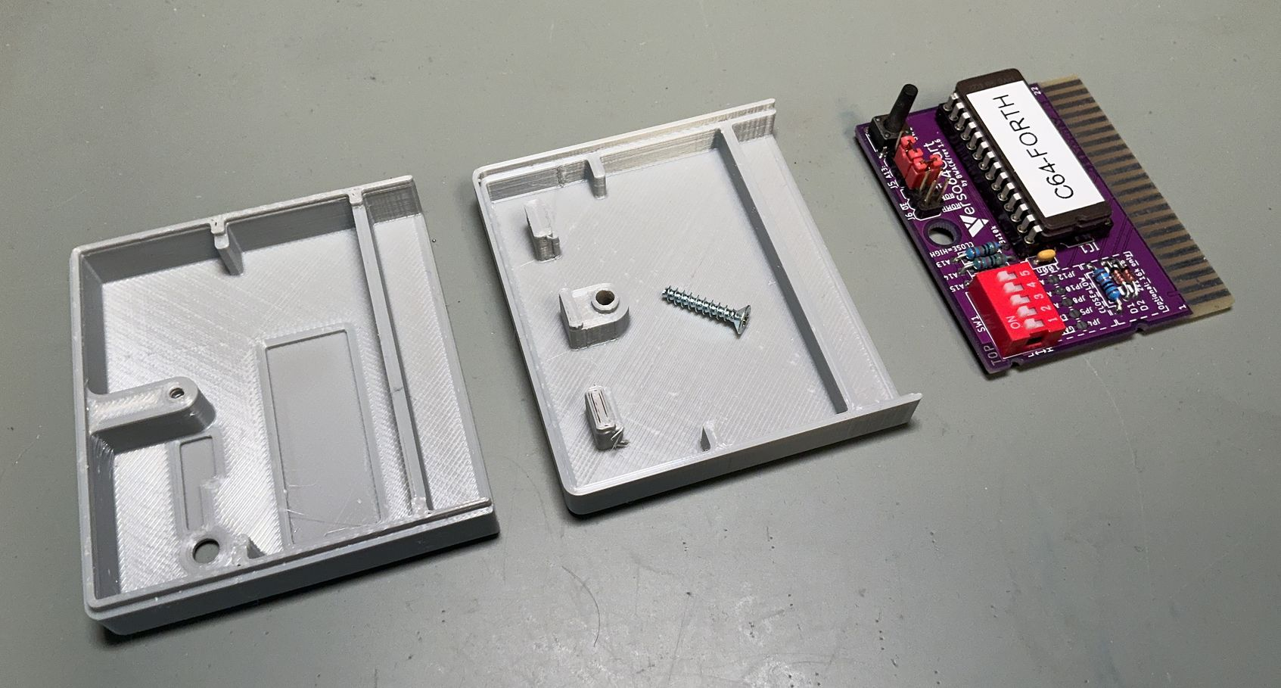

Figure 6: Closed version without configuration access

In case short pin headers and (open) jumpers are used, they will fit under the case.

# The Reset Switch

Originally, the reset switch on the Versa64card has a height of 7mm. For this case a TACT switch with a total height of 11.0mm -12.5mm is recommended. The distance between the top surface of the case and the top surface of the PCB is 10.8 mm.

# Recommended screws

Countersunk, self-tapping screws with a total length of 13.0mm to 16.0mm and a diameter of 2.9mm (C2.9 x 13 or C2.9 x 16) are recommended. E.g. DIN 7982 or DIN 7983.

# Revision History

## Rev. 0

* Working prototype